Matthew Tran
Linus Command Line Practice (BASE)
This allowed me to set up a base for my future activities using Linux. The purpose of this lab allowed me to practice essential terminal skills by navigating, creating, and managing files and directories using basic Linux commands.

Tools Used

- Linux terminal
- Bash shell

Skills Learned

- Customizing the terminal prompt using export PS1
- Navigating the filesystem with cd, pwd, and ls
- Using both absolute and relative paths to move between directories
- Listing and filtering directory contents with ls, ls -l, and ls -d
- Viewing file contents with tail, file, and tail -n+
- Creating, copying, moving, renaming, and deleting files and directories using mkdir, cp, mv, touch, and rm
- Performing file and directory management with superuser privileges using sudo

Task 1) Customize Terminal Prompt

I opened a terminal and used export PS1="Matthew Tran@vm" to personalize my command prompt. This makes it easier to identify my terminal session in a multi-user environment.
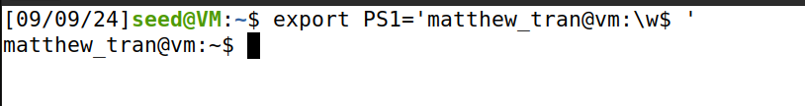
Task 2) Identify Current Location and Directory Contents
I used pwd to confirm my current location in the filesystem (/home/student), establishing my starting point. Then, I ran ls to list the contents of the directory, which helped me understand what files and folders were available before continuing.

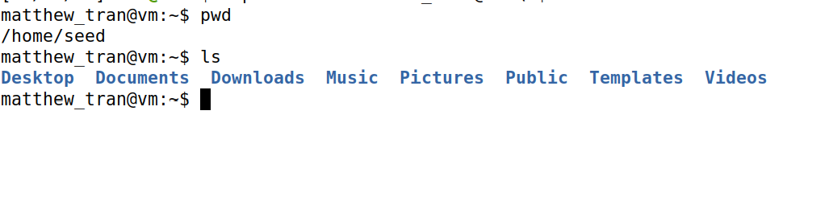
Task 3) Navigate Using an Absolute Path.
I used cd /etc to navigate directly to the system configuration directory. This demonstrates how absolute paths allow movement from anywhere in the filesystem to a specific location.

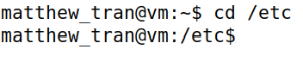

Task 4) Navigate Using a Relative Path
From /etc, I ran cd skel to enter the skeleton directory. This shows how relative paths enable navigation from the current directory without retyping the full path.
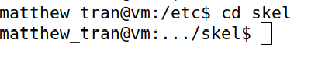

Task 5) Move to Parent Directory
I used cd .. to move back to the parent directory (/etc). This is needed for efficient directory traversal without memorizing full paths.

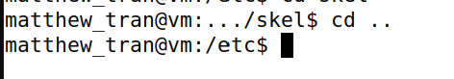

Task 6) List Directory Contents

I ran ls to view all files and subdirectories in /etc. This command is fundamental for exploring directory contents and understanding system structure.

Task 7) See More Details About Files
I used ls -l to see extra info like who owns each file, when it was made, and how big it is.
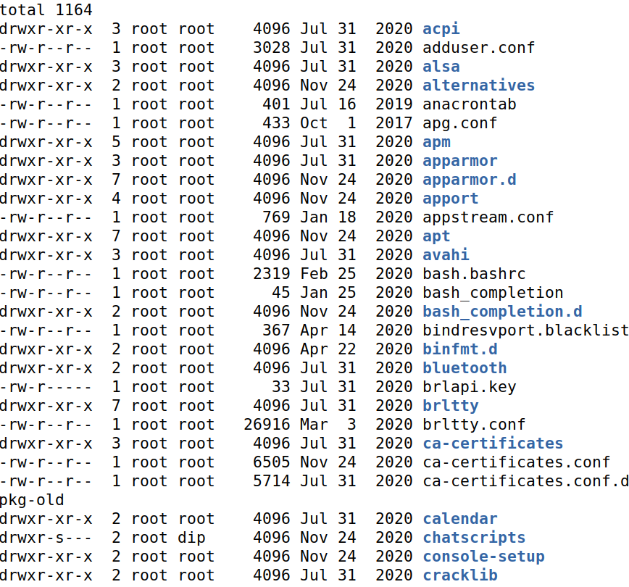

Task 8) Only Show Files Starting with ‘s’
I typed ls -d s* to only list items in /etc that start with the letter “s”.

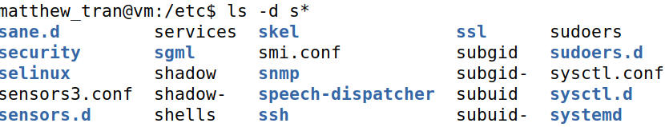

Task 9) Find Out What Kind of File /etc/group Is
I used file /etc/group to check what type of file it is.

Task 10) Look at the Last 5 Lines of a File
I typed tail -n 5 /etc/group to see only the last 5 lines of the /etc/group file.

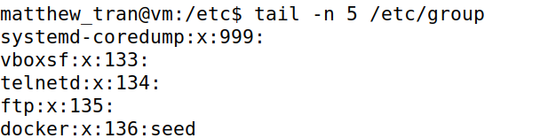

Task 11) View a File Starting at Line 20
I used tail -n+20 /etc/passwd to look at the /etc/passwd file starting from line 20 to the end.
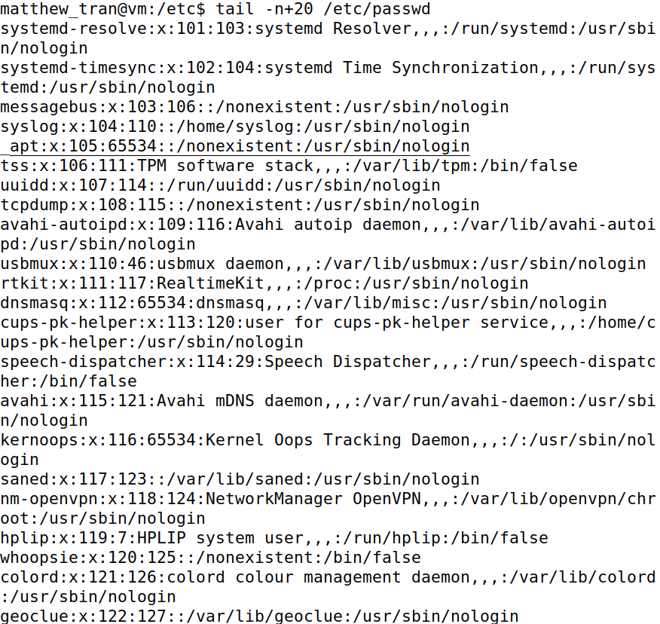

Task 12) Go Back to Your Home Folder
I typed cd ~ to go straight back to my home folder

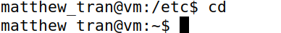

Task 13) Make a New Folder and Check It
I made a folder called data with mkdir data, then used ls to see that it was created.

Task 14) Copy a System File into Your Folder
I copied /etc/passwd into my data folder using cp /etc/passwd data/.

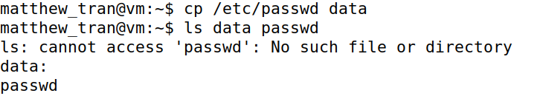

Task 15) Copy a Whole System Folder
I used sudo cp -r /etc/ppp . to copy the entire /etc/ppp folder into my current location. I needed sudo because it’s a protected system folder.
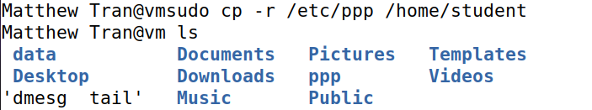
Task 16) Rename a Folder
I changed the name of the ppp folder to peers with mv ppp peers.
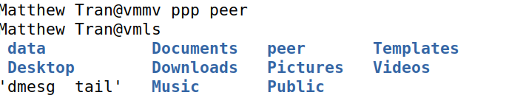

Task 17) Make an Empty File
I created an empty file named test inside the data folder using touch data/test.
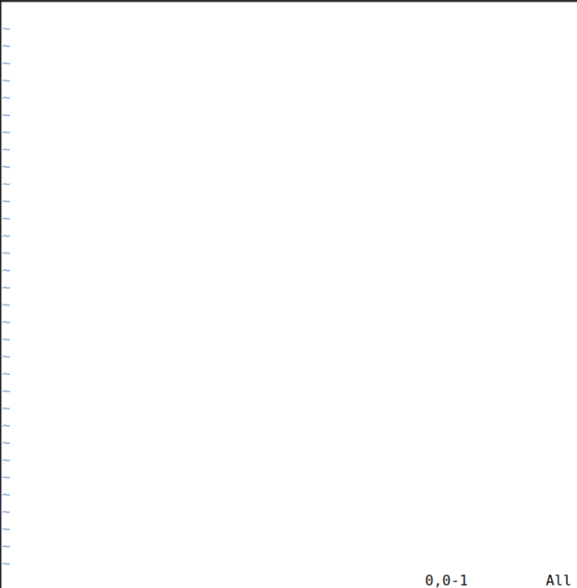

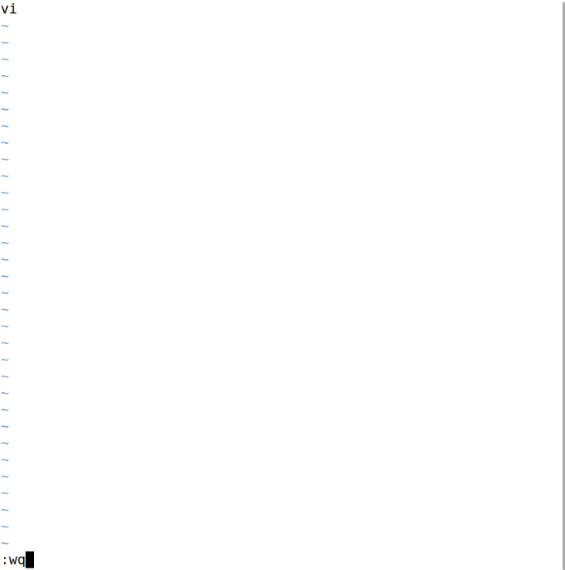
In the screenshot above, I used “:wq” to save the file and exit vi. Next, I will move the test file into the data directory using mv.

Task 18) Remove a File
I deleted the passwd file from the data folder using rm data/passwd.
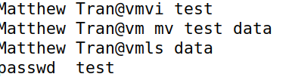
Task 19) Remove a Folder and Everything Inside
I deleted the peers folder and all its contents with rm -r peers.

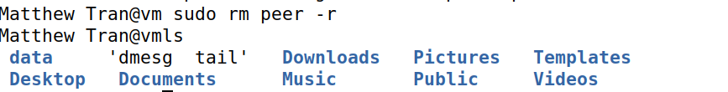
Every command I ran had a clear job, like moving, checking, or cleaning up.

